Lecture-16

What Is Azure Load Balancer?
Azure load balancer allows you to distribute traffic to your backend pool which can contain virtual machines or virtual machine scale set or containers. An Azure load balancer provides high availability for your application. The Azure load balancer is a fully managed service itself.

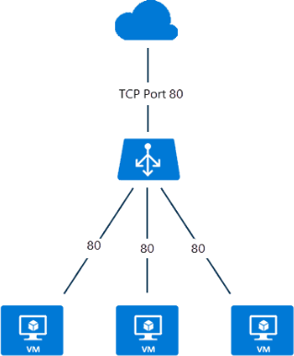

Load balancer use 5 tuple or data points hasing algorithm to distribute the traffic. These are as below:

- Source IP address: The IP address of the device sending the request.
- Source port: The port number used by the application on the source device.
- Destination IP address: The IP address of the Azure Load Balancer itself.
- Destination port: The port number the client is trying to reach on the backend server.
- Protocol type: This specifies TCP or UDP, the type of communication used.

Why Choose Azure Load Balancer?

With Standard Load Balancer, you can scale your applications and create highly available services. Load balancer supports both inbound and outbound scenarios. A load balancer provides low latency and high throughput and scales up to millions of flows for all TCP and UDP applications.
Some of the key scenarios that you can accomplish using Standard Load Balancer include:
- Load balance internal and external traffic to Azure virtual machines.
- Increase availability by distributing resources within and across zones.
- Use health probes to monitor load-balanced resources.
- Employ port forwarding to access virtual machines in a virtual network by public IP address and port.
- Standard Load Balancer provides multi-dimensional metrics through Azure Monitor. These metrics can be filtered, grouped, and broken out for a given dimension. They provide current and historic insights into the performance and health of your service. Resource Health is also supported.
- Load balance services on multiple ports, multiple IP addresses, or both.

What are the types of load balancer in Azure?
In Azure, you can create two types of the load balancer
- Public load balancer
- Internal/ private load balancer
Public Load Balancer: A public load balancer can be used to load balance internet traffic to virtual machines. It can provide outbound connections for virtual machines (VMs) inside your virtual network.

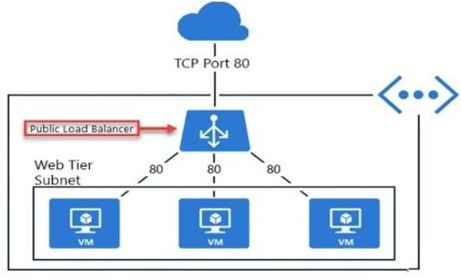

Internal/ Private Load Balancer: An internal (or private) load balancer is used to balance traffic from within a virtual network.
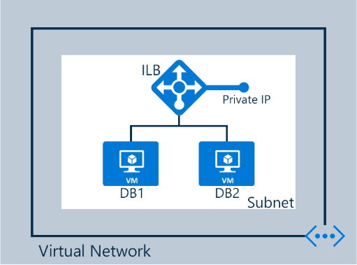

Along with load balancer, there are two pricing tiers available Basic and Standard
Basic: Basic tier load balancer provides basic features and is restricted to some limits for backend pool size it is restricted to only 300 instances, it’s restricted to a single availability set and it only supports multiple frontends for inbound traffic. This will be retiring soon
Standard: Standard tier load balancer is generally available and offers higher-scale and new features. It is a paid-for feature using a complex set of consumption-based charges and the Basic tier continues to be free. Also, we can scale out to 1000 instances and can span any virtual machine in a single virtual network, including blends of scale sets, availability sets, and machines.

Features Of Azure Load Balancer

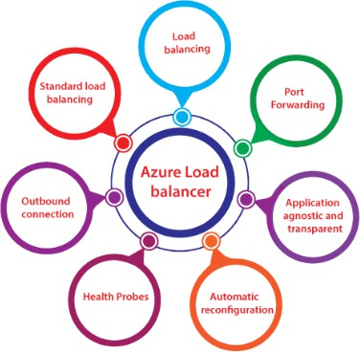

- Load Balancing: Azure load balancer uses a 5-tuple hash that contains source IP, source port, destination IP, destination port, and protocol.
- Outbound connection: All the outbound flows from a private IP address inside our virtual network to public IP addresses on the Internet can be translated to a frontend IP of the load balancer.
- Automatic reconfiguration: The load balancer is able to reconfigure itself when it scales up or down instances on the basis of conditions. So, if more virtual machines are added into the backend pool, automatically load balancer will reconfigure.
- Application agnostic and transparent: It doesn’t directly interact with TCP or UDP protocols. We can route the traffic based on URL or multi-site hosting
- Health probes: When any failed virtual machines in a load balancer are recognized by the health probe in the backend pool then it stop routing the traffic to that particular failed virtual machine. It can configure a health probe to determine the health of the instances in the backend pool.
- Port forwarding: The load balancer supports port forwarding ability if we have a pool of web servers, and we don’t want to attach a public IP address for every web server in that pool.

Azure Load Balancing Rules
  - Load balancing rules define how to route traffic when it arrives on the load balancer
  - These rules can use to redirect traffic into the backend pool
  - You can also enable session persistence- Here’s client IP’s can be directed to the same backend virtual machines

